## In the partial fulfilment of

**Master of Science – MscIT Sem 5**



**L.J School of Computer Applications, LJKU**

Project Management System

### Developed by: Guided by:

**Name: Thakkar Divy** Name of the internal guide

**Enrollment: 21004500210183**

**Name: Shah Daksh**

**Enrollment: 21004500210144**

**Name: Sakshi Jani**

**Enrollment: 21004500210052**

### L.J. INSTITUTE OF COMPUTER APLLICATIONS

Near Nagdev Kalyan Mandir, Near Sanand Cross Roads,

Serkhej-Gandhinagr Highway Ahmedabad – 382210

Ph. No. : 9099063417



#### CERTIFICATE

**Enrollment No**: 21004500210183 **Seat No:** _

This is to certify that **Thakkar Divy** of Master of Science (MSc.IT), Semester V,

Roll No **63** has satisfactorily completed his/her Project titled **Project Management System**

in **Django** under the supervision of internal guide.

**Internal Guide: HOD:**

Name of the internal guide Dr. Jignesh Doshi

**Date of Submission:**

### L.J. INSTITUTE OF COMPUTER APLLICATIONS

Near Nagdev Kalyan Mandir, Near Sanand Cross Roads,

Serkhej-Gandhinagr Highway Ahmedabad – 382210

Ph. No. : 9099063417



#### CERTIFICATE

**Enrollment No**:21004500210144 **Seat No:** _

This is to certify that **Shah Daksh** of Master of Science (MSc.IT), Semester V,

Roll No **50** has satisfactorily completed his/her Project titled **Project Management System**

in **Django** under the supervision of internal guide.

**Internal Guide: HOD:**

Name of the internal guide Dr. Jignesh Doshi

**Date of Submission:**

### L.J. INSTITUTE OF COMPUTER APLLICATIONS

Near Nagdev Kalyan Mandir, Near Sanand Cross Roads,

Serkhej-Gandhinagr Highway Ahmedabad – 382210

Ph. No. : 9099063417



#### CERTIFICATE

**Enrollment No**:21004500210052 **Seat No:** _

This is to certify that **Jani Sakshi** of Master of Science (MSc.IT), Semester V,

Roll No **19** has satisfactorily completed his/her Project titled **Project Management System**

in **Django** under the supervision of internal guide.

**Internal Guide: HOD:**

Name of the internal guide Dr. Jignesh Doshi

**Date of Submission**

|  |  |  |
| --- | --- | --- |
| **Sr.**  **No.** | **TABLE OF CONTENTS** | **Page No.** |
| **1.** | **INTRODUCTION** |  |
|  | 1.1 Existing System |  |
|  | 1.2 Need for the New System |  |
|  | 1.3 Objective of the New System |  |
|  | 1.4 Problem Definition |  |
|  | 1.5 Core Components |  |
|  | 1.6 Project Profile |  |
|  | 1.7 Assumptions and Constraints |  |
|  | 1.8 Advantages and Limitations of the Proposed System |  |
| **2.** | **REQUIREMENT DETERMINATION & ANALYSIS** |  |
|  | 2.1 Requirement Determination |  |
|  | 2.2 Targeted Users |  |
| **3.** | **SYSTEM DESIGN** |  |
|  | 3.1 Use Case Diagram |  |
|  | 3.2 Class Diagram |  |
|  | 3.3 Interaction Diagram |  |
|  | 3.4 Activity Diagram |  |
|  | 3.5 Data Dictionary |  |
| **4.** | **DEVELOPMENT** |  |
|  | 4.1 Coding Standard |  |
|  | 4.2 Screenshots |  |
| **5.** | **AGILE DOCUMENTATION** |  |
|  | 5.1 Agile Project Charter |  |
|  | 5.2 Agile Roadmap / Schedule |  |
|  | 5.3 Agile Project Plan |  |
|  | 5.4 Agile User Story (Minimum 3 Tasks) |  |
|  | 5.5 Agile Release Plan |  |
|  | 5.6 Agile Sprint Backlog |  |
|  | 5.7 Agile Test Plan |  |
|  | 5.8 Earned-value and burn charts |  |
| **6.** | **PROPOSED ENHANCEMENTS** |  |
| **7.** | **CONCLUSION** |  |
| **8.** | **BIBLIOGRAPHY** |  |

**1.** Introduction

* 1. **Existing System :-**

Existing system of system of project management is manual. Project leader or guide gives task for employee manually. An Employee complete the work which is given by leader or guide and submits manually, in this system all work is done by manually so it can take more time to complete project related work. Project leader or guide requires remembering in mind when employee completed the work so it is difficult for Project leader or guide which employee completed the task and when. In the existing system does not help users to get right information at right time and user cannot manage project development easily to achieve the main goal.

* 1. **Need for the New System :-**

Project Management System’s aims to increase the productivity of employees involved in project management by Assigning Project. which is used by companies to plan, coordinate, and control distributed projects

**1.3 Objective of the New System :-**

Project Management Systems help in project management by allowing Employee to share information and work on allocated tasks. These tools can help improve communication and coordination among employee and project leader, making tracking progress and deadlines easy.

**1.4 Problem Definition :-**

Project Management System could be simply defined as all the task management, communication and resource management software features, apps and platforms that allow project managers to manage their employee's workflow.

**1.5 Core Components :-**

* It Provides many functionality like:

Assign Project

Review Project

Requirement Gathering

Upload Project

**1.6 Project Profile :-**

|  |  |
| --- | --- |
| **Project Title** | **Project Management System** |
| **Front-end** | **HTML5, CSS3, Bootstrap4** |
| **Back End** | **My SQL , Django** |
| **Server** | **Apache (Tomcat 9.0)** |
| **Other Tools** | **Power Point, MS Word - 2019** |
| **Diagram Builder** | **Dia.de ,draw.io** |

* 1. **Assumptions and Constraints :-**

**1.8 Advantages and Limitations of the Proposed System :-**

The advantages of using these system include increased productivity, better communication between employee members, easier access to files and documents, improved project management capabilities.

1. **REQUIREMENT DETERMINATION**

**& ANALYSIS**

**2.1 Requirement Determination :-**

Requirement analysis is an element of project management that helps ensure clarity, completeness, and relevance. The goal is to define expectations for a project. The requirements may apply to software development, process improvement, or a new technology purchase.

**2.2 Targeted Users :-**

* Students
* Teacher
* I.T. Companies
* Employee
* Project leaders

**3. SYSTEM DESIGN**

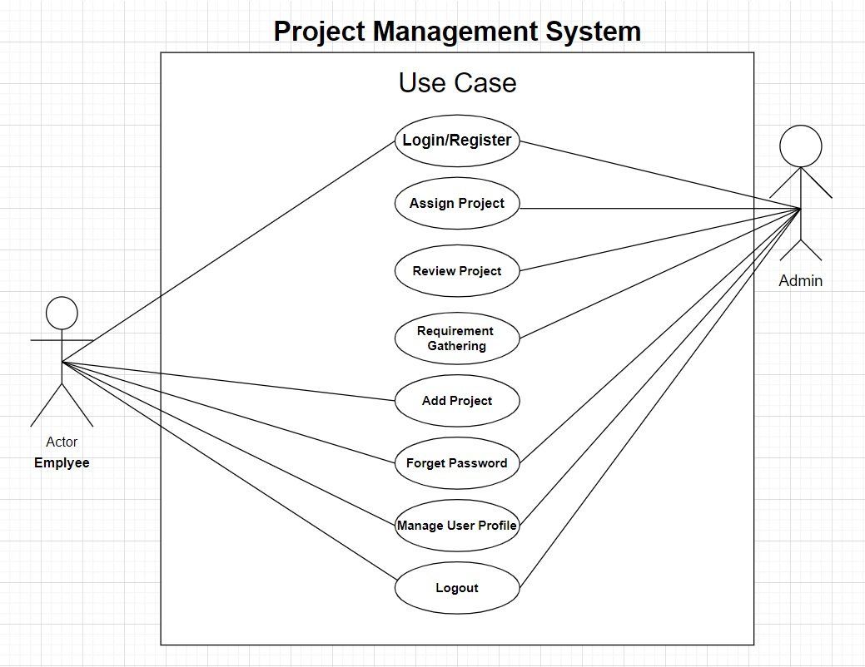 **3.1 Use Case Diagram :-**

**3.4** **Activity Diagram :-**

* “An activity diagram for **Assigning Project By Admin** ”

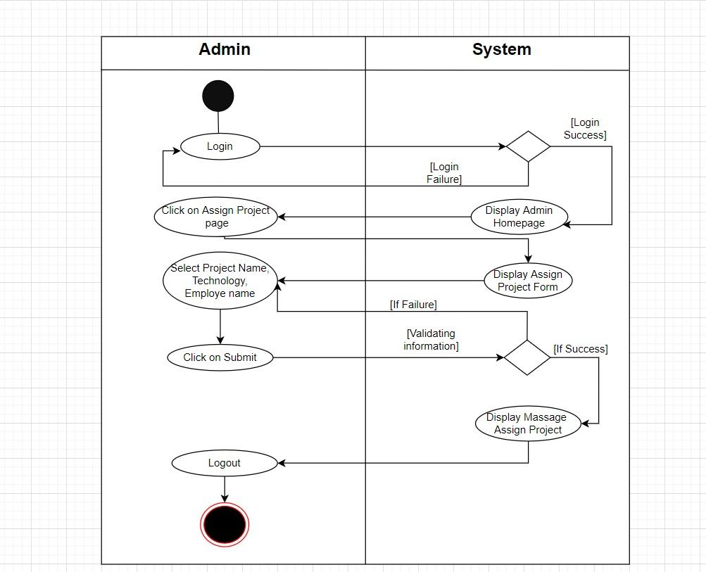

* “An activity diagram **Add Project** **By Employee**”

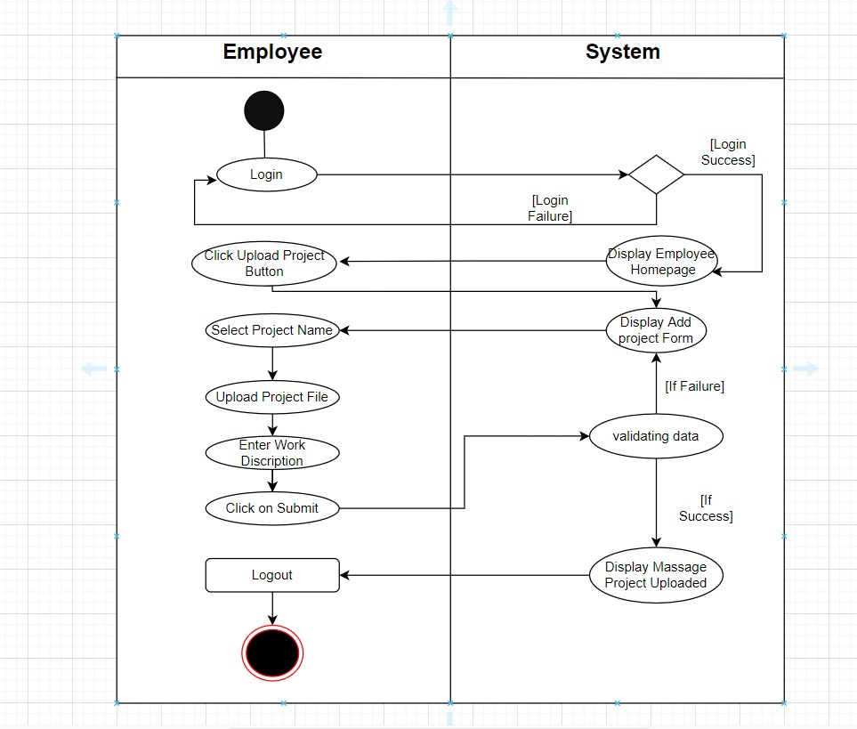

**3.5 Data Dictionary :-**

**“Admin_Login”**

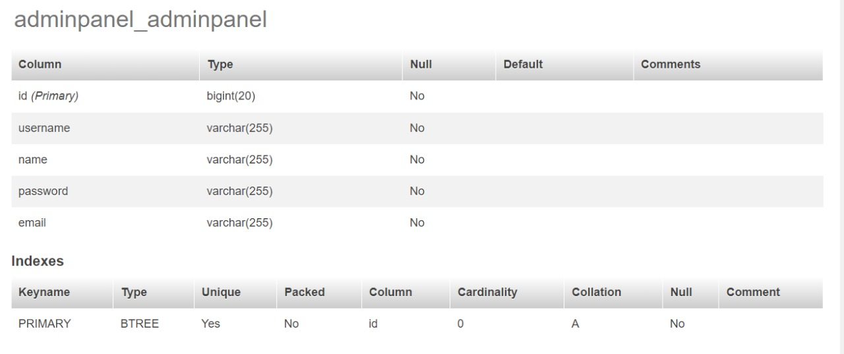

**“Pending_Projects”**

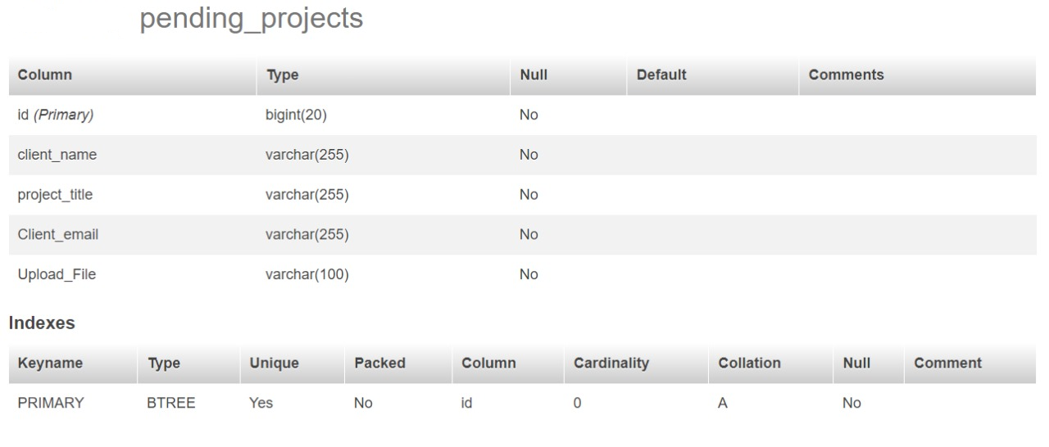

“**UserModel”**

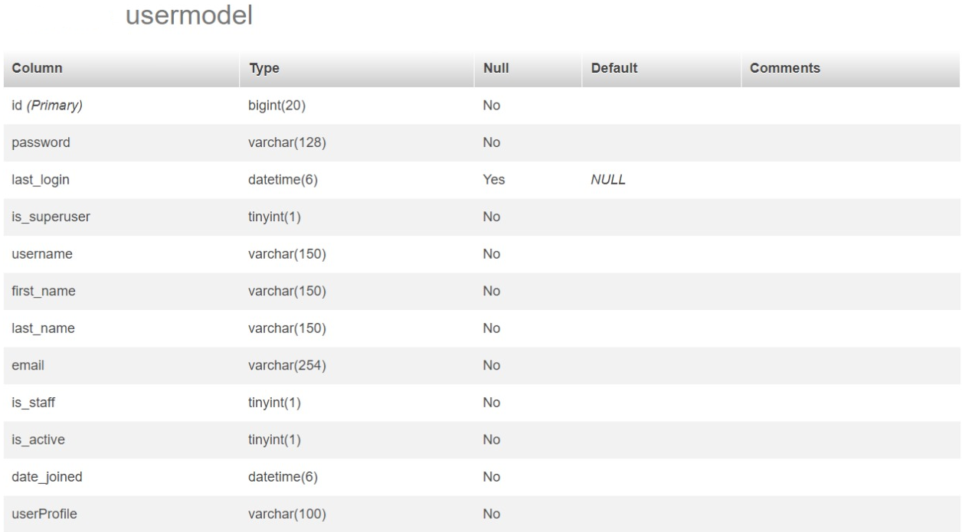

**4. Development**

**4.1 Coding Standard :-**

**4.2**  **Screenshots :-**

**7. CONCLUSION**

Project Management System is a very effective application which can be used to a great extent. It have many advantages over the traditional system. Some of these advantages are centralized data, up-to-date status reporting, ease of use, backups etc. It also provides a good interface which is easy to understand by the users and helps in adapting to the use of this web application.